**PRACTICAL - 8**

**AIM:** To study and design 4 bit synchronous Up-Down Counter.

THEORY:

In a sequential circuit the present output is determined by both the present input and the past output. In order to receive the past output some kind of memory element can be used. The memory element commonly used in the sequential circuits are time-delay devices. The block diagram of the sequential circuit-

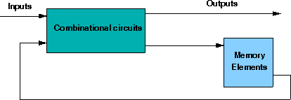

A circuit with flip-flops is considered a sequential circuit even in the absence of combinational logic. Circuits that include flip-flops are usually classified by the function they perform. One such circuit is counter:

**Counter** is essentially a register that goes through a predetermined sequence of states.

There are various different kind of Flip-Flops. Some of the common flip-flops are: R-S Flip-Flop, D Flip-Flop, J-K Flip-Flop, T Flip-Flop. But we will use JK flip Flop here and convert it in to T Flip Flop.

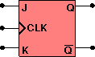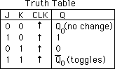**JK flip flop:** If J and K are both low then no change occurs. If J and K are both high at the clock edge then the output will toggle from one state to the other.

**T flip flop**: The T or "toggle" flip-flop changes its output on each clock edge.

# Some of the main points about Synchronous Counters:

* Synchronous Counters can be made from Toggle or D-type flip-flops.
* Synchronous counters are easier to design than asynchronous counters.
* They are called synchronous counters because the clock input of the flip-flops are all clocked together at the same time with the same clock signal.
* Due to this common clock pulse all output states switch or change simultaneously.
* With all clock inputs wired together there is no inherent propagation delay.
* Synchronous counters are sometimes called parallel counters as the clock is fed in parallel to all flip-flops.
* The inherent memory circuit keeps track of the counters present state.
* The count sequence is controlled using logic gates.
* Overall faster operation may be achieved compared to Asynchronous counters.

# Synchronous Binary up Counter:

A counter is a sequential circuit that moves through a predefined sequence of states upon applying of clock pulses. The sequence of states may follow the binary number sequence or an arbitrary manner (no sequence). The simplest example of a counter is the binary counter which follows the binary number sequence. An n-bit binary counter contains n flip-flops and can count binary numbers from 0 to (2n -1)(up counter which is incremental, if it counts decremental it is then down counter). Logic diagram of 4 bit synchronous up counter and its waveform -

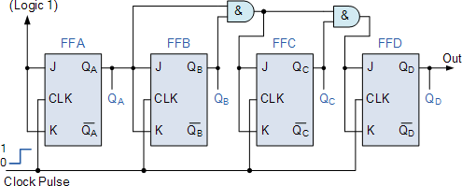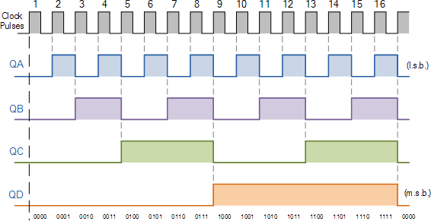

# Synchronous Binary up-down (bi-directional) Counter:

Both Synchronous and Asynchronous counters are capable of counting “Up” or counting “Down”, but there is another more “Universal” type of counter that can count in both directions either Up or Down depending on the state of their input control pin and these are known as Bidirectional Counters.

Bidirectional counters, also known as Up/Down counters, are capable of counting in either direction through any given count sequence and they can be reversed at any point within their count sequence by using an additional control input as shown below.

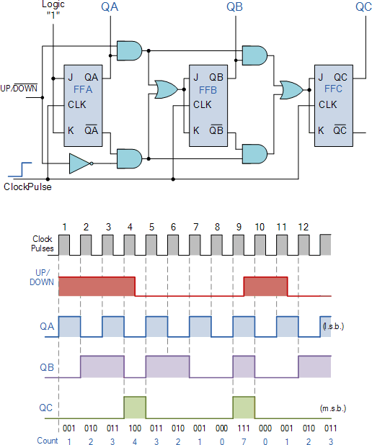

# Components:

1. JK Flip Flop
2. OR, AND and NOT gate

# LABWORK:

1. 4-bit UP Counter

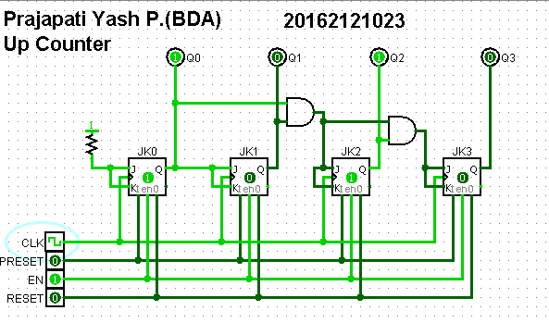

2. 4-bit DOWN Counter

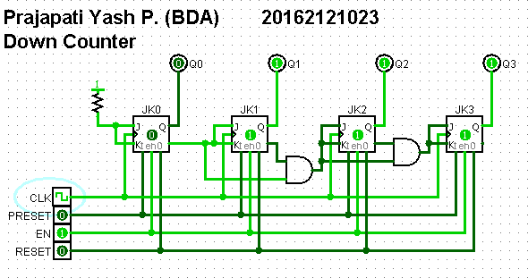

3. 4-Bit UP/DOWN Counter

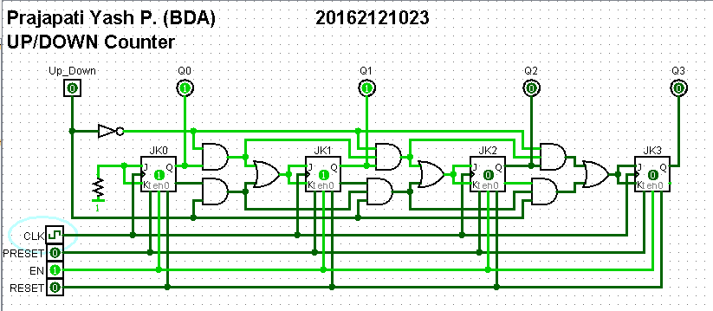

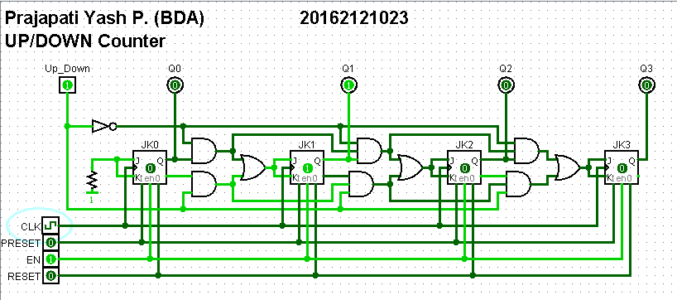

**CONCLUSION: -**

* Hence by studying and analyzing the circuit and the outputs we conclude the study and design 4 bit synchronous Up-Down Counter.